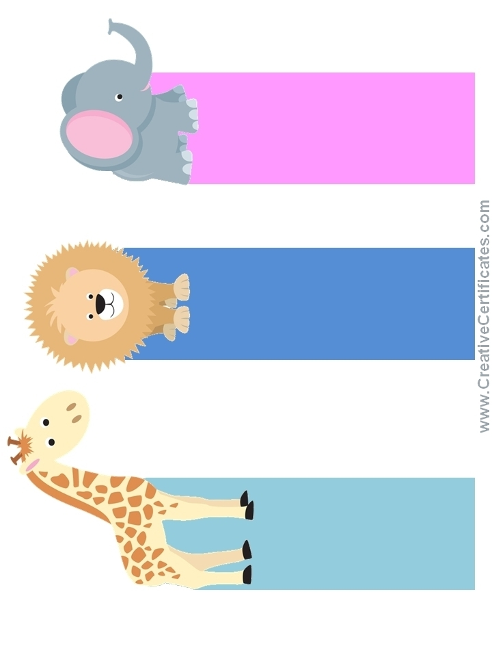

Well Done!

Excellent!

Good Job!

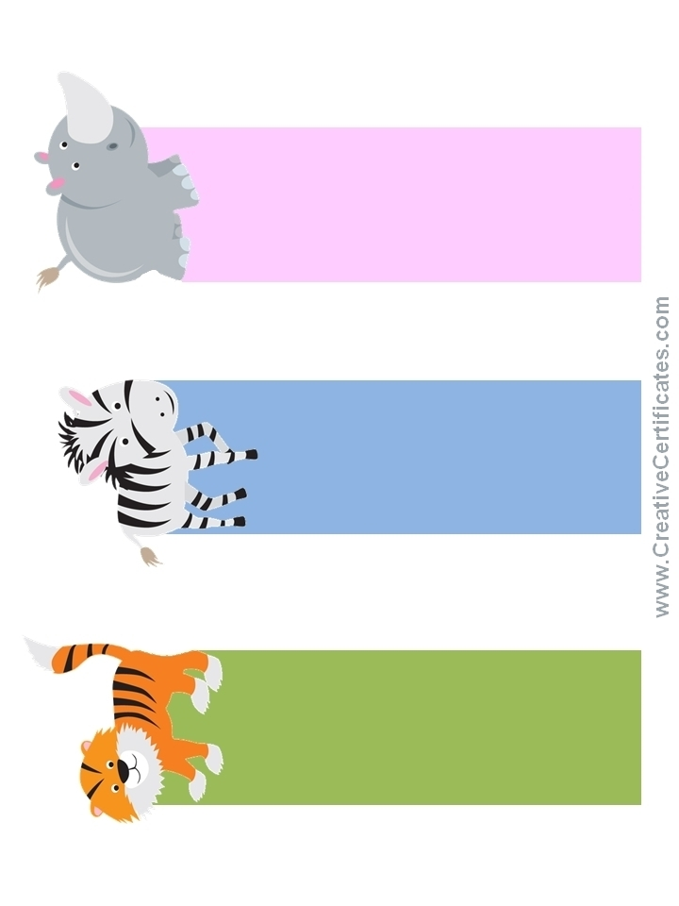

Good Effort!

Good Job!

Well Done!